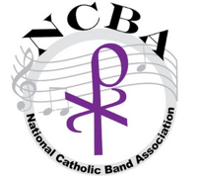

Creating your digital video for the NCBA OUTSTANDING CATHOLIC CONCERT BAND IN THE UNITED STATES

- Use any video recording of your band performing 2 selections that directors have listed on the application.
- Do not include the name of the school in the video so that judges will be able to keep the schools’ identity anonymous
- Submissions can be from different video recordings, as long as the selections being performed are the same as listed on the application.
- Submissions may be from either a concert, a rehearsal, or local competition.
- Video Recordings must be a clean audio track. Audience noise and talking will make it difficult to hear the bands performance.
- Video Submissions should be through one of the follow methods:
- Unlisted YouTube video link
- Google Drive Link with "Anyone who has link" sharing so that staff and judges will have access without requiring extra permission.
- Dropbox link

All videos should be in the MP4 format.

If you have any questions about submissions, please reach out to our webmaster, John Donovan at jdonovan@stritahs.com

ALL RECORDINGS MUST BE SUBMITTED ELECTRONICALLY BY APRIL 30, 2024 TO

NCBAHONORSENSEMBLES@GMAIL.COM

WINNERS WILL BE ANNOUNCED ON MAY 7, 2024

